
QUALITY ALERT

Customer: AMERILUX Date: Apr 17, 2025
Die: 15191 Colour: All
Type of Complaint: Customer REJECTED

Q.A # Q.I.R # CUSTOMER NCR #

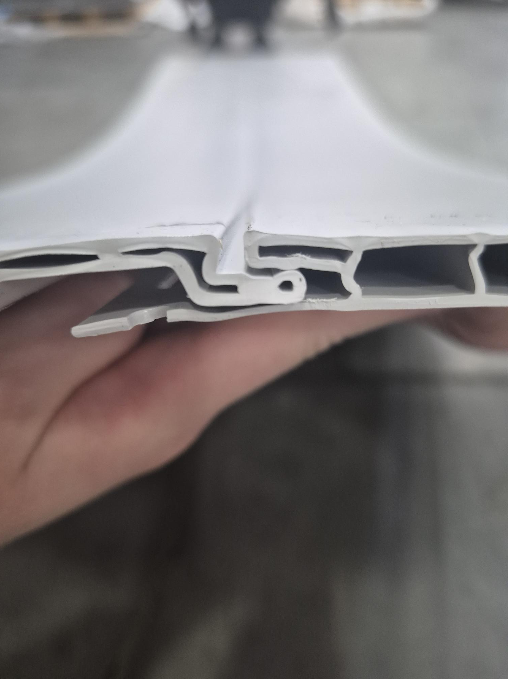
Description: Customer REJECTED material due to female lip is too small, part can’t fit in.

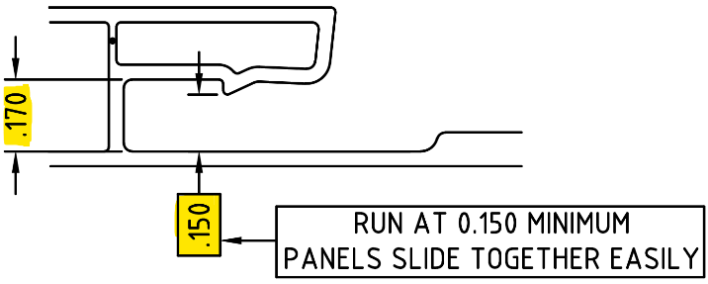
ASSEMBLY PART GOT STUCK HERE BECAUSE THIS GAP IS TOO SMALL

CRITICAL

PLEASE MAKE SURE TO CHECK THIS AREA FOR FIT & FUNCTION

BY SIGNING BELOW, YOU ACKNOWLEDGE THE PROBLEM ABOVE AND AGREE TO MONITOR THIS ISSUE IN FUTURE PRODUCTION RUNS.
DAY SHIFT |  | AFTERNOON SHIFT |  | NIGHT SHIFT
NAME | SIGNATURE | NAME | SIGNATURE | NAME | SIGNATURE

